Free Heat Pump
Valued at $6499
With EVERY POOL*
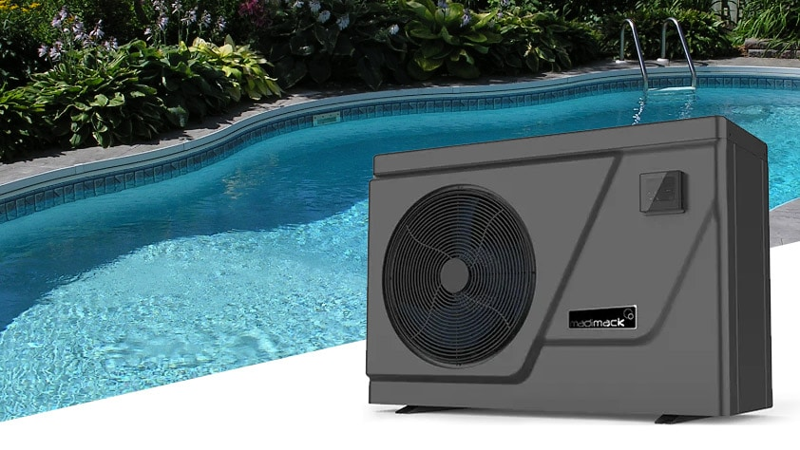

Call or email now oipools@outlook.com or 03 57 431 060

Includes a 19kw Heat pump with every signed contract in April /May 2024 with installation in 2024

